**PYTHON ASSINGMENT**

Name: ?????

Section: CSE – D

# Python program to print SONA COLLEGE

ALGORITHM

* Step 1: Start
* Step 2: print “SONA COLLEGE”
* Step 3: Stop

CODE

# **Python program to print SONASONASONA**

ALGORITHM

* Step 1: Start
* Step 2: Print “SONASONASONA”
* Step 3: Stop

CODE

# **Python program to perform arithmetical operations**

ALGORITHM

* Step 1: Start
* Step 2: Get a,b
* Step 3: Sum of a,b stored in A
* Step 4: Subtraction of a.b stored in S
* Step 5: Multiple of a,b stored in M
* Step 6: Division of a,b stored in D
* Step 7: Print A,S,M,D
* Step 8: Stop

CODE

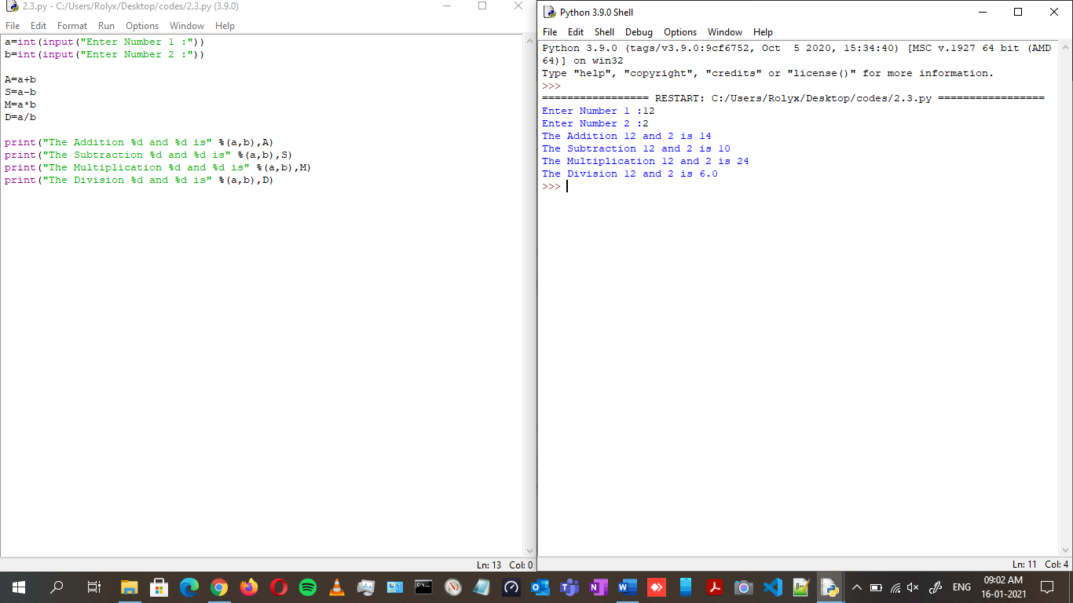

# **Python program to find the area of triangle**

ALGORITHM

* Step 1: Start
* Step 2: Get BASE and HEIGHT of the Triangle
* Step 3: Print the Area of the Triangle using ( b*h/2 )
* Step 4: Stop

CODE

# **Python program to convert kilometres to miles**

ALGORITHM

* Step 1: Start
* Step 2: Get the Kilometre
* Step 3: Multiply the kilometre with 0.6214
* Step 4: print the miles
* Step 5: Stop

CODE

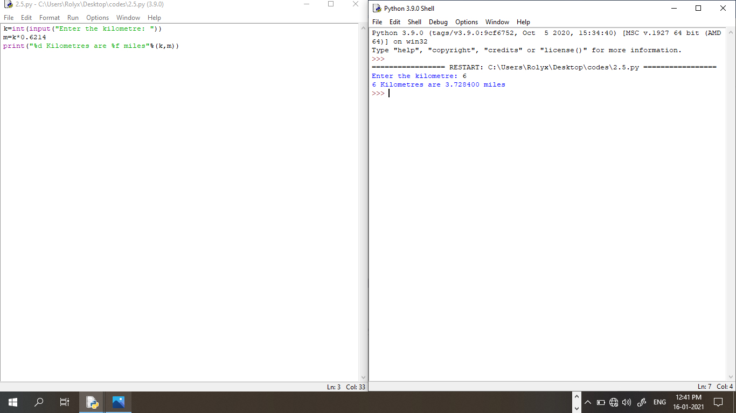

# **Python program to convert celsius to Fahrenheit**

ALGORITHM

* Step 1: Start
* Step 2: Get the Celsius value
* Step 3: Calculate the Celsius with (C * 9/5) + 32
* Step 4: Print the Fahrenheit
* Step 5: Stop

CODE

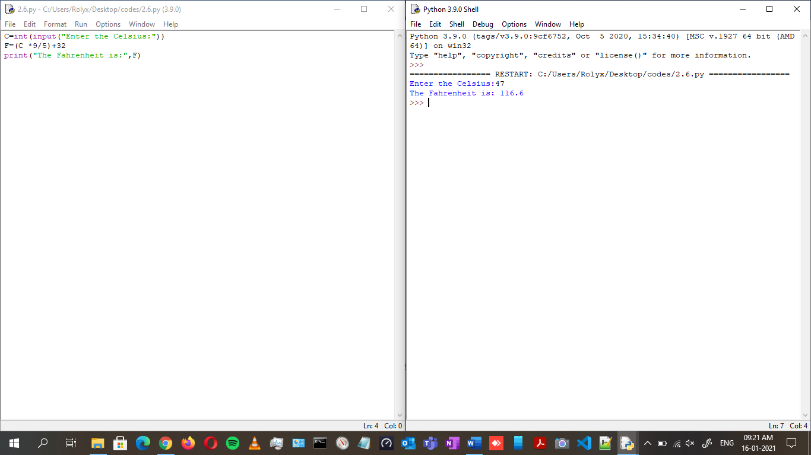

# **Python program to get multiple values in a single line**

ALGORITHM

* Step 1: Start
* Step 2: Get input n,a,d in single line using “.split()”
* Step 3: Print n,a,d
* Step 4: Stop

CODE

